**This is a description of the general procedure when designing a fixed wing UAS, as described by Giuseppe Landolfo in his thesis titled *Aerodynamic and Structural Design of A Small Nonplanar Wing UAV.*** While most of this paper is about nonplanar wing design, I have found a lot of useful information in Chapter III Design Requirements and Chapter IV Aircraft Initial Sizing. I have taken a few screenshots of the REALLY useful tables and figures that I thought would be awesome information to use.

1. This method was designed for a fixed wing UAS with the following requirements:

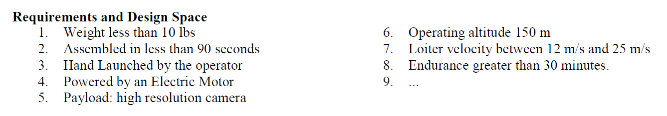

The table below shows a general outline of features for previous successful fixed wing UAS:

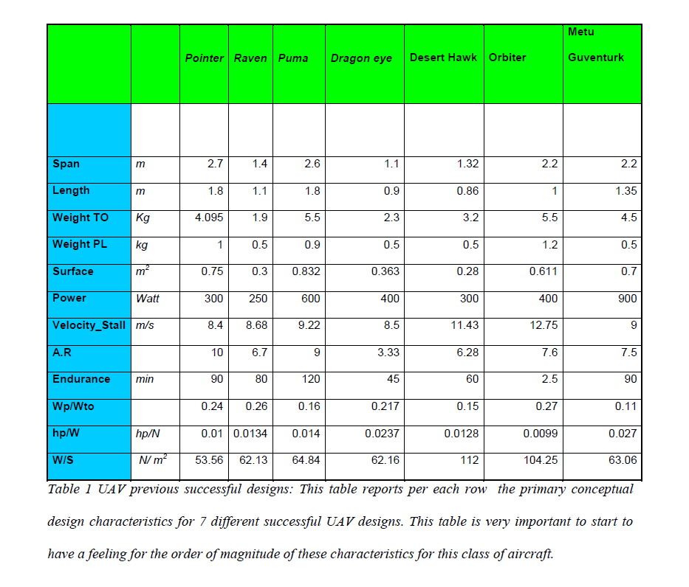

1. The first important step is to determine what the weight of your payload will be. This is where we will decide what sensors we believe are necessary for our UAS. Once we determine the weight of our sensors, parallela board and any other payload, we will know our approximate take-off weight. Below is a table which shows the payload weight fractions of previously successful UASs. It was found that the average Wp/Wto fell around 0.201.

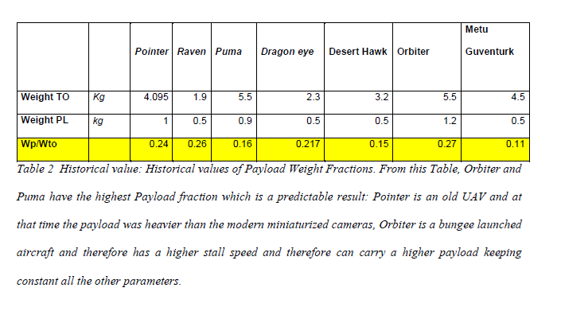

1. After determining the take-off weight, we will now pick a design point. Using the horsepower to weight ratio vs wing loading diagram below, we are able to see the general design space in which we can work with. By picking a design point, we are then able to determine what the surface area of our wing will be as well as the thrust available.

**In general:**

**-An aircraft with a higher hp/W ratio will accelerate more quickly, climb more rapidly, reach a higher max speed, and sustain higher turn rates**

**-The Wing Loading (W/S) affects the stall speed, climb rates, takeoff/landing distances, turn performances, Cl and drag. A larger wing will typically have a low wing loading – this may improve the performance of the aircraft, but it will also increase drag. It is important to find a good compromise when it comes to wing loading.**

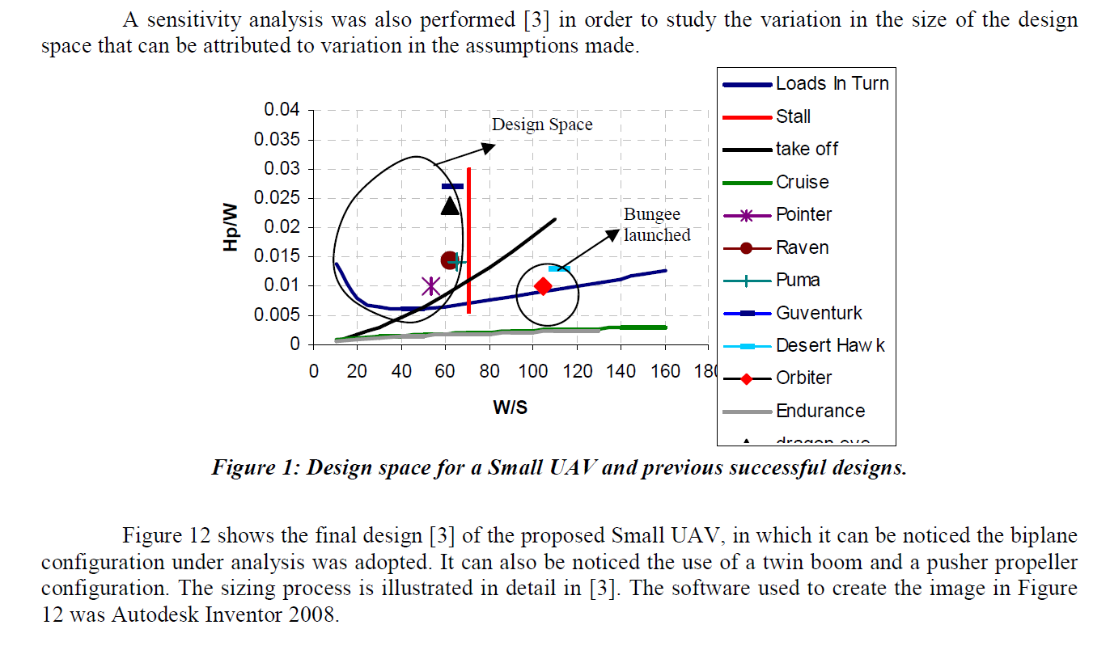

1. Once we have picked a design point, we have the capability to determine the wing geometry. We will determine the surface area of the wing by using the formula S=W/(W/S) since we know the weight of our aircraft as well as the wing loading. At this point we will pick an aspect ratio of our choice. I suggest that we use some of the tables to see what previous aircrafts have used in order to make an educated decision about what will work best for ours. Once the aspect ratio is decided, we can calculate the span and chords (very simple multiplication calculations which are shown in the paper).
2. At this point we can start determining some of the flight characteristics of our aircraft, and we can make an initial estimate of our operating lift coefficient, drag coefficient and lift to drag ratio. We can determine the operating lift coefficient by: $C_{L}=\frac{W}{\frac{1}{2}ρV^{2}S}$ where we have determined W/S, rho, and we can pick an arbitrary V cruising speed. From this point we will determine our first lift to drag ratio estimate by analyzing our airfoil as a flat plate (only for aspect ratio > 4. We know that the coefficient of lift is a function of the angle of attack defined by $C_{L}=2πα$. We also know the induced drag coefficient is defined by $C_{Di}=\frac{C_{L}^{2}}{πeAR}$. An assumption was made in the paper that the parasitic drag is approximately 0.03. Using these assumptions, we are able to draw a graph of the lift to drag ratio (L/D) as a function of the angle of attack. This allows us to determine our operating lift to drag ratio corresponding to our operating angle of attack (which is determined by the previously defined formula $C_{L}=2πα$ at the operating lift coefficient found in the step above). The example of this step from the paper is shown below:

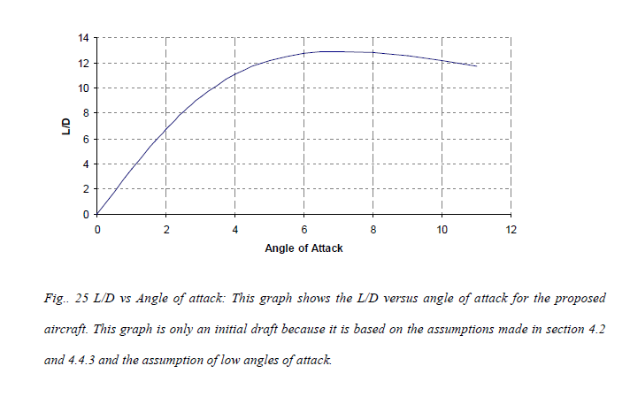

1. At this point we are able to start making decisions about the battery/motor combination. The graph below shows how the weight of the battery will have an effect on the thrust performance of the aircraft

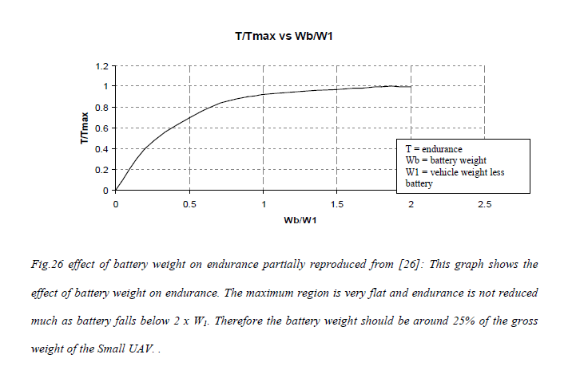

We can see that in order to achieve maximum performance, the battery should encompass approximately 25% of the weight of the UAS. In section 4.4.4.3 of the paper, there is a really good description which will help us calculate the power that will be required to operate our UAS at different angles of attack. We will decide the angle of attack that our UAS needs to be able to sustain which will give us the corresponding power requirement. Using this requirement, we will be able to make decisions about what size and kind of battery will be required in order to operate our UAS, as well as choose a propulsion system. Below is the example from the paper of what the power requirement is with respect to angle of attack:

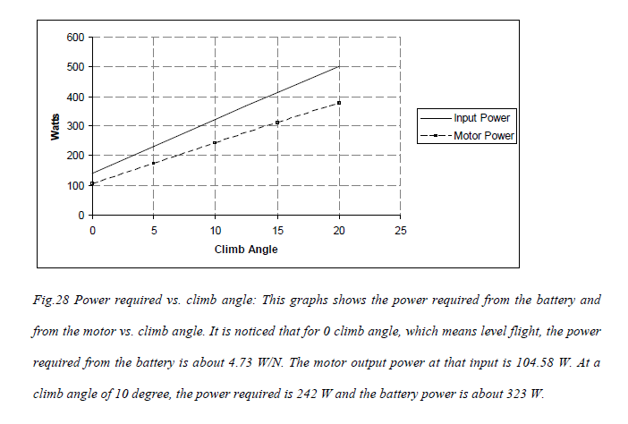

Raven/Pointer?!:

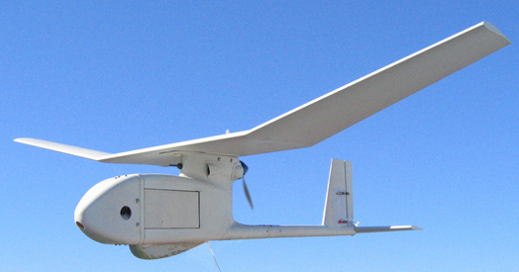

**WASP**

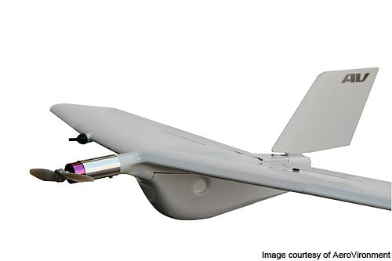

**General characteristics**

* **Crew:** none
* **Length:** 1.25 ft (38 cm)
* [**Wingspan**](https://en.wikipedia.org/wiki/Wingspan)**:** 2.375 ft (72.3 cm)
* **Height:** ()
* [**Empty weight**](https://en.wikipedia.org/wiki/Manufacturer's_empty_weight)**:** 0.95 lb (430 g (Land version))
* **Loaded weight:** 14.4 lbs (6.53 kg)
* [**Powerplant**](https://en.wikipedia.org/wiki/Aircraft_engine)**:** 1 × Electric motor, rechargeable lithium ion batteries, ()

**Performance**

* **[Maximum speed](https://en.wikipedia.org/wiki/V_speeds" \l "Regulatory_V-speeds):** 40mph 65 km/h
* **[Cruise speed](https://en.wikipedia.org/wiki/V_speeds" \l "Vc):** 40 - 65 km/h
* [**Range**](https://en.wikipedia.org/wiki/Range_(aeronautics))**:** 5 km ()

**PUMA**

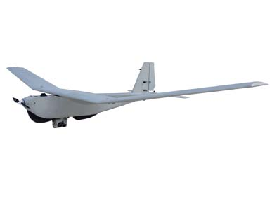

**DESERT HAWK**

